Canadian Association for Italian Studies (CAIS)
2019 Conference
Orvieto (TR) Italy
June 13-16

HOTEL BOOKING FORM
You are kindly requested to complete this form and return it at your earliest convenience
prior to April 30th, 2019 to: raffaele@effegiviaggi.it

NAME
SURNAME
PHONE NUMBER
E-MAIL:
ADDRESS
POSTAL CODE
CITY / TOWN
COUNTRY
FISCAL CODE (Italians only)

BEDDING OPTION number of rooms requested |  | HOTEL
Check In /June/ 2019 | Check Out / June/ 2019

A limited number of rooms have been blocked by Effegi Viaggi.
Reservation are accepted on “first come, first served” base. Please note that your request can only be considered a definite booking after you have received a confirmation from Effegi Viaggi
We will attempt to give you another option if your choice is unavailable, depending on availability.
Payment upon arrival
PLEASE PROVIDE YOUR CREDIT CARD NUMBER FOR THE CONFIRMATION AND GUARANTEE OF YOUR RESERVATION.

You may pay upon arrival, with cash or by credit card.
Booking will not be processed if this section is not completed.

Credit Card Card No. Expiry Date (mm/yy)

Cardholder Name

To confirm your reservation Effegi Viaggi will send you a voucher with all the booking details

CANCELLATION POLICY:
Rooms may be cancelled up to May 13, 2019 free of charge.
Rooms may be cancelled up to June 12, 2019 with a one night penalty.
No-shows or early departures must pay full price.

HOTEL AVAILABILITY
ORVIETO HISTORIC CENTRE

RATES PER PERSON PER NIGHT
4 STAR HOTEL
HOTEL PICCOLOMINI OR HOTEL AQUILA BIANCA
SINGLE € 65,00
DOUBLE FOR SINGLE USE € 75,00
DOUBLE/TWIN € 45,00
TRIPLE € 40,00
CITY TAX € 2,50 PER PERSON PER NIGHT
3 STAR HOTEL
HOTEL CORSO OR HOTEL VALENTINO OR GRAND HOTEL REALE
SINGLE € 60,00
DOUBLE FOR SINGLE USE € 70,00
DOUBLE/TWIN € 42,00
TRIPLE € 35,00
CITY TAX € 2,30 PER PERSON PER NIGHT
3 STAR HOTEL SUPERIOR
HOTEL VIRGILIO

SINGLE € 95,00
superior DOUBLE/TWIN € 80,00
small DOUBLE/TWIN € 60,00
TRIPLE € 60,00
CITY TAX € 2,30 PER PERSON PER NIGHT
B&B
SINGLE min. € 50,00 – max € 60,00
DOUBLE FOR SINGLE USE min. € 60,00 – max € 70,00
DOUBLE/TWIN min € 40,00 – max € 50,00
TRIPLE min € 30,00 – max € 40,00
CITY TAX € 2,30 PER PERSON PER NIGHT

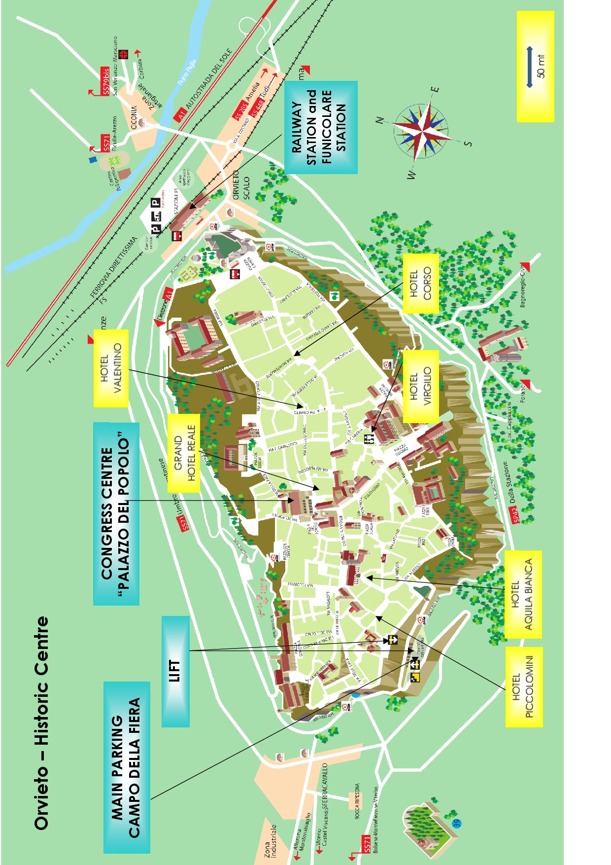
Orvieto is located in the province of Terni, in the southwest area of Umbria, at an altitude of 325 meters above sea level. It has a population of about 21,500 and is most notable for wine, Umbricelli (pasta), black truffles, and olive oil. The city is perched on a tufa rock and is surrounded by many small towns, the largest of which is Ciconia (a modern residential area that is continuously expanding). Orvieto also overlooks a picturesque valley and the Paglia and Chiani rivers.
The city is divided into the Orvieto Historic Center and Orvieto Scalo. There are buses that connect Orvieto Scalo and Orvieto Center with neighboring towns. The Funicular conveniently connects Orvieto Scalo with the town center and stops at the top of the rock in Piazza Cahen. The Funicular is a modern and fast method of transportation between the top and bottom of the rock. It is now mechanically operated which replaced the old hydraulic-powered cable car of Giacomo Bracci and designer Adolfo Orvieto Cozza. Taxis are also available in Piazzale Matteotti in front of the train station.

How to get to Orvieto
Orvieto is located in the south-east of Umbria, on the border of Lazio (Viterbo) and southern Tuscany (provinces of Grosseto and Siena). The city is well served by the rail network from the highway.

Getting to Orvieto by Car
From the A1 motorway exit directly at the Orvieto toll booth and follow the signs for the Center, located about 4.5 km from the motorway. The city is located about an hour’s drive from Rome and 1 hour and 40 minutes from Florence.
Arriving by car from the south: ROMA – ORVIETO
Arriving by car from the north: FIRENZE – ORVIETO
Coming from the main regional road E 45 (from Perugia-Assisi) take the Orvieto exit; from there take the road that runs along the Corbara Lake for about 30 minutes to reach Orvieto. Other main towns in Umbria, like Perugia, Assisi, and Terni, are also easily accessible via road E 45. It takes about half an hour to travel from Orvieto-Todi following signs for Perugia.
Another way to arrive to Orvieto by car is by the Cassia road (coming from south, Viterbo-Rome), which descends from the Buonviaggio-Villanova towns with a panoramic view of the city.

Getting to Orvieto by Bus
Two local companies (Busitalia and Cotral) provide urban and extraurban services to reach surrounding towns like Bagnoregio, Acquapendente, Bolsena, Porano, and Allerona.

The bus station is located in Piazza Matteotti (in front of the train station and next to the funicular), while the parking lot for the tourist bus is in the large parking in Piazza della Pace (below the train station). It’s a pay parking area for buses (€45.00 per day). More info about tourist bus parking fee and regulation here: www.orvietoviva.com/en/orvieto-parking/

Getting to Orvieto by Train
Orvieto is located on the Rome-Florence-Milan line and very accessible by train. The train station, bus station and the Funicular are all located in Piazzale Matteotti in Orvieto Scalo. Orvieto’s train station is on a main route that travels from Rome to Milan and passes through major cities including Florence, Arezzo and Bologna. From the city you can easily take the train to Rome (1 hours) and Florence (approx. 2 hours).
For information on arrival abd departure times from Rome or Florence to Orvieto visit: www.trenitalia.it
Arriving by train from the south: ROMA TERMINI – ORVIETO
Arriving by train from the north: FIRENZE – ORVIETO
At the Orvieto train station, in Piazza della Pace (below the train station) you can also find a luggage service. Visit this page for more details: www.orvietoviva.com/en/orvieto-train-station/

Getting to Orvieto by Plane
The closest major airports are Rome-Ciampino and Rome-Fiumicino (Leonardo da Vinci). The latter is about 1.5 hours from Orvieto and can be reached via the A1 motorway.
About 1 hour from Orvieto is the Perugia “San Francesco da Assisi” airport (in the area of Sant ‘Egidio) which offers low-cost airline options.

